SAN−G WALL

Generic Name by SUCAMEC: NON-SENSITIZED BULK EMULSION OR HYDROGEL

DESCRIPTION AND COMPOSITION:
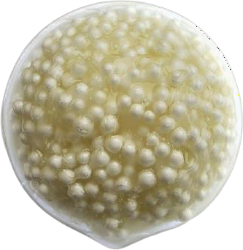
SAN-G WALL is part of FAMESA EXPLOSIVOS S.A.C.'s family of bulk explosives, which includes products designed for dry, water and dewatered blasting applications, in addition to providing the widest range of densities of bulk explosives.
SAN-G WALL is not explosive until after being sensitized with expanded polystyrene beads produced on-site in the factory truck before loading into the boreholes.

USES:
When SAN-G WALL is sensitized on-site, it forms a blasting agent characterized by its low density and detonation velocity. It is used to control the damage induced to the rock mass walls due to the energy distribution within the borehole, reducing the risk of partial slope detachment and offering greater safety in explosion works.
SAN-G WALL with this range of density can be charged directly into the drill holes under the dry hole system.
The handling temperature range of the SAN-G WALL is from 0°C up to 40°C. For different temperatures it is recommended to contact the Technical Assistance area.

TECHNICAL CHARACTERISTICS:

UNIT SAN-G WALL

Matrix emulsion density | g/cm3 | 1.32 ± 3%
Density of sensitized matrix emulsion | g/cm3 | 0.60 to 0.80
Velocity of Detonation (*) | m/s | 3 000 to 4 000
Detonation pressure | kbar | 14 to 32
Energy | kcal/kg | 516
Normal volume of gases | l/kg | 1 150
Relative power by weight (**) | % | 55
Relative power by volume (**) | % | 48
Water resistance | --- | Low
Fume category | --- | Class 1
Critical diameter | “ | 6
Sensitivity to initiation | --- | Booster HDP -1 (450 g)
Time of permanence in the drill hole (***) | days | 7
(*) Detonation velocity confined in 6-inch diameter pipe.
(**) Relative powers referred to ANFO, with conventional power of 100. (***) Applies to heavy ANFO mixtures and gasified emulsions.

The values expressed are results at normal conditions (25°C and 1 atm.)

PACKAGING:
SAN-G WALL is presented in bulk and transported safely in tank trucks.

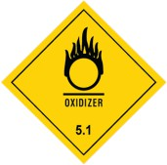
TRANSPORT:
Class : 5
Division : 5.1 UN No. : 3375

STORAGE AND WARRANTY:
SAN WALL should be stored in magazines at temperatures between 0°C and 40°C, located in safe, well ventilated, dry areas, protected from rain and heat. Also, the explosive inventory should be rotated, avoiding the use of new materials before using old ones. And it must be stored according to the current compatibility table of the relevant authority.
SAN-G WALL kept in its original packaging and stored in the above-mentioned temperature conditions has a warranty period of 3 months after its production date.

WARNING:
FAMESA EXPLOSIVOS S.A.C. has safe products, but they may become dangerous elements in inexperienced hands.
The purchaser or user must comply with the applicable regulations during transport, storage and use, as well as train duly all its personnel involved in its loading and handling, providing mechanical aids for loads over 25 kg per person.
FAMESA EXPLOSIVOS S.A.C. assumes no liability for transport, storage and/or improper use their products may experience.
The information and recommendation described in this document do not necessarily cover all product applications nor the different conditions under which it is being used. These are based on the experience, research and tests done by Famesa Explosivos S.A.C., who does not guarantee favorable results nor assume any responsibility, expressed or implied, in relation to the use of these suggestions. This product may be changed without prior notice.

